|  |
| --- |
| Functional test cases -  Correction |
| DMS H7 |

|  |
| --- |
| Test Scenarios – Correction  May 2021 |
|  |

# Document version

|  |
| --- |
|  |
| Document version:   |  |  |  |  | | --- | --- | --- | --- | | Version nr. | Dato | Created by | Updates | | 1.0 | 11-05-2021 | Emma Hagerup |  | |

Table of Content

1 Document version 1

2 Introduction 3

2.1 Test data and preconditions 3

2.2 Process flow 3

2.3 Test Scenarios 3

3 Detailed test scenarios 5

3.1 Scenario 1: Correction application rejected based on format validation 5

3.2 Scenario 2: Correction application rejected based on content validation 5

3.3 Scenario 3: Correction application with notification of granted request 7

# Introduction

The purpose of this test is that the economic operator (EO) can make changes on an already existing declaration before the declaration has been presented. This is called a correction. A correction is sent by the EO to the DMS ERMIS system. A declarant can be allowed to make changes on a declaration which has not had the goods presented, which is also called a pre-lodged declaration or an IMD declaration. All fields (except the MRN) can be corrected.

## Test data and preconditions

To be able to do this test the EO must send a declaration/correction with the following AS4 Business Services:

* DMS.Import.Declaration.Submit
* DMS.Import.Declaration.Amend

To endpoint:

https://secureftpgatewaytest.skat.dk:6384/exchange/CVR_<CVR>_UID_<UID>

## Process flow

The process flow for a correction application of an already existing pre-lodged declaration can be seen in Figure 1 below.

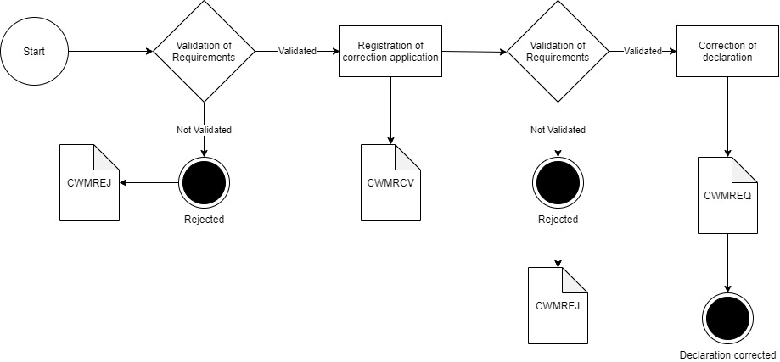

Figure 1

## Test Scenarios

To complete the functional onboarding phase two, the OE must deliver confirmation of passed test-cases for each test scenarios:

|  |  |  |
| --- | --- | --- |
| **Test no** | **Test Scenario** | **Passed** |
| **1** | Send correction application which is synchronously rejected based on format validation | ☐ |
| **2** | Send correction application which is rejected based on content validation. | ☐ |
| **3** | Send correction application and receive notification of decision on request | ☐ |

Figure 2 shows the process flow divided into the above mentioned 3 scenarios.

Figure 2

# Detailed test scenarios

The following sections will describe the aim of the specific test scenarios and it will provide the desired results of the test. It should be noted that there can be changes in the notifications provided by the DMS solution, because the solution is still in development. If at a later point more notifications will be added the EO will be informed about this and the EO will be requested to complete the test again.

## Scenario 1: Correction application rejected based on format validation

The following sections will describe the aim of the test and it will provide the relevant test data and results of the test.

The aim of scenario 1 is to test if the EO can send a correction application and get a synchronous rejection. The rejection is based on a failed syntax validation, so to trigger this a correction application with an erroneous .xml is sent.

**Success**

For this test case to succeed, the correction application should be rejected based on a syntax error. This error will be sent in a synchronous response.

**Test data example**

The following test data should be used:

* Submit initial H7 pre-lodged declaration: *IMD.xml* (remember to fill in LRN)
* Test for wrong format by sending a correction application with wrong syntax in field FunctionCode:

<ns2:FunctionCode>H</ns2:FunctionCode>

* Fill in the syntax error XML: *Corr_scenario_1.xml* with preferred LRN and assigned MRN and submit the XML.

## Scenario 2: Correction application rejected based on content validation

The following sections will describe the aim of the test and it will provide the relevant test data and results of the test.

The aim of scenario 2 is to test if the EO can obtain notification that the correction application request has rejected.

**Success**

A notification has been successfully requested and received.

**Test data example**

The following test data should be used:

* Submit initial H7 declaration: *IMD.xml* (remember to fill in LRN)
* Test for wrong content by sending a correction application with wrong content in field Exporter country code:

<ns2:Exporter>

…

<ns2:CountryCode>DS</ns2:CountryCode>

…

</ns2:Exporter>

* Fill in the syntax error XML: *Corr_scenario_2.xml* with preferred LRN and assigned MRN and submit the XML.
* Since the application is manually handled by a customs officer you should contact you assigned onboarding contact person when the application has been successfully sent.

Do following steps:

* + Write an email to your onboarding contact person with the following information:
    - Which application was sent (in this case: a correction application for rejection)
    - MRN
    - LRN

Your onboarding contact person will then deny the correction application which fulfills Scenario 3.

* Pull notification to see notification of denied correction application.

## Scenario 3: Correction application with notification of granted request

The following sections will describe the aim of the test and it will provide the relevant test data and results of the test.

The aim of scenario 3 is to test that the EO can obtain notification that the original declaration can be corrected.

For the test to succeed the EO should be able to receive notifications about acceptance of the correction application.

**Test data example:**

The following test data should be used:

* Submit initial H7 declaration: *IMD.xml* (remember to fill in LRN)
* Test for correct content by sending a correction application with correctly corrected content in field Exporter Name:

From:

<ns2:Exporter>

<ns2:Name>Exporter Name</ns2:Name>

…

</ns2:Exporter>

To:

<ns2:Exporter>

<ns2:Name>Texporter Name</ns2:Name>

…

</ns2:Exporter>

* Fill in the correct correction XML: *Corr_scenario_3.xml* with preferred LRN and assigned MRN and submit the XML.
* Since the application is manually handled by a customs officer you should contact you assigned onboarding contact person when the application has been successfully sent.

Do following steps:

* + Write an email to your onboarding contact person with the following information:
    - Which application was sent (in this case: a correction application)
    - MRN
    - LRN

Your onboarding contact person will then grant the correction application which fulfills Scenario 3.

* Pull notification to see notification of granted correction application.

#Decorative

|  |  |  |  |
| --- | --- | --- | --- |
|  | www.ufst.dk  ISBN |  | Udviklings- og Forenklings- styrelsen er en del af  Skatteforvaltningen |